Positive Media Coverage on the Proposed Changes to the Smoke-Free Ottawa Public Places Bylaw (Volume 3)
February 14-21, 2012

News Articles

Ottawa Citizen

NCC may follow city’s lead on outdoor smoking ban

By Neco Cockburn, The Ottawa Citizen, February 17, 2012

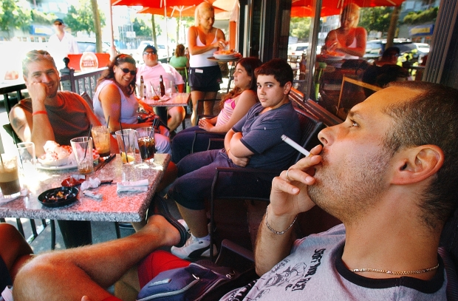

A ban on smoking on outdoor patios is among the measures to be considered by Ottawa council.

Photograph by: Peter Battistoni, Vancouver Sun

OTTAWA — The National Capital Commission would likely follow the City of Ottawa’s lead if a proposed outdoor smoking ban is implemented on municipal properties, its chief executive says, meaning a sweeping prohibition might apply across the capital.

“If they go ahead with it, chances are we will too,” Marie Lemay said on Friday.

“We share event sites, and we share parks. You can’t have some parks that are on one side of the street where you can have smoking and the other one you can’t. At one point, there has to be some consistency,” she said.

Should the NCC go ahead with a ban similar to what city officials have proposed, smoking might be prohibited on commission pathways and parklands, as well as outside its properties and at festivals on its land, such as Bluesfest.

Speaking to reporters after providing city councillors with an update on the commission’s Horizon 2067 visioning exercise, Lemay said the NCC would have to look at details regarding issues such as enforcement of any smoking ban.

It was not immediately clear what might happen on NCC properties in Gatineau.

No timeline has been set, Lemay said, but “we’re following very closely what the city’s doing, because obviously the minute they go ahead with this it will definitely impact us, so we’re proactively looking into this.”

The city’s proposed prohibition applies to smoking outside municipal facilities such as arenas and City Hall, and at parks, playgrounds, beaches and bar and restaurant patios. It would also apply to festivals and other events on city properties.

The required bylaw amendments are to go to council on Wednesday, following approval this past week from council’s community and protective services committee.

Several councillors and Mayor Jim Watson have spoken in favour of the new rules, and it’s expected they will be approved. If so, tickets would be issued as of July 2, after a warning phase beginning April 2.

Similar rules on NCC properties would provide a level playing field for areas like the ByWard Market, where restaurants and bars would otherwise face competition from festivals on NCC lands where people are allowed to smoke, the executive director of the ByWard Market Business Improvement Area has argued.

“Allowing festivalgoers to continue to smoke on NCC lands creates an unfair advantage for festivals and events over bars and restaurant owners,” Jasna Jennings told the committee this past week.

The city’s proposed smoking ban would also apply to vendor stands at the Parkdale and ByWard markets.

The bylaw amendments are part of a three-year renewed smoke-free strategy, approved by the board of health, that would also increase services and programming to help people stop smoking, and provide public education campaigns and a community engagement plan.

EMC – Ottawa South

City moves to ban smoking at patios, beaches, parks

By Laura Mueller
Posted Feb 16, 2012

EMC news - Smokers should butt out on restaurant patios as well as city-owned parks, beaches, buildings and markets, the city's public health board is recommending.

A decade after the city banned smoking indoors, the next phase of the bylaw expansion would make all city properties - including beaches, more than 1,000 parks and 300 city facilities, including the Byward and Parkdale market stalls - smoke-free zones. Smoking on city streets and sidewalks would still be allowed.

More controversial will be the push to keep smoking out of restaurant and pub patios.

But the policy got resounding support from around 20 delegates who presented at a Feb. 7 meeting that resulted in the health board endorsing the plan.

"Who would of thought you'd be here to tell us we're foot dragging and not moving fast enough ... we thought we were being cutting edge," said Somerset Coun. Diane Holmes, who chairs the board.

Other municipalities have done "bits and pieces" of what Ottawa is proposing, said the city's medical officer of health, Dr. Isra Levy, but he added: "We believe the comprehensiveness of what's being done here puts Ottawa back on top."

The popularity of voluntary smoke-free signs in parks is growing, and the proposed bylaw expansion reflects that public desire for more smoke-free spaces, Holmes said.

Ottawa public health has been consulting residents and businesses on the plan for the past year.

"It's clear that people want this," Holmes said.

Smokers were included in the consultation, and they generally supported the recommendation, although in smaller numbers than the general population, Levy said.

"We're seeing a respect for non-smokers," he said.

The expanded bylaw will be discussed by the community and protective services committee on Feb. 15 and would need council's final approval on Feb. 22.

The health board added a component to the plan by asking the city health board to write to local MPs and MPPs advocating changes to the Smoke-Free Ontario Act to include water pipes or hookahs in the scope of smoking products the city can regulate.

Fines of $305 could be handed out to people smoking in restricted areas after July 2, with a warning period from April 2 to July 2.

The expanded bylaw won't require any additional funds to enforce, according to the report.

A couple of presenters at the Feb. 7 health board meeting questioned whether the expanded bylaw could be effectively enforced without more money. Glebe resident Catherine Caule said she worried the smoke-free bylaw expansion would "cannibalize" resources from other bylaw programs such as noise enforcement.

Ottawa public health staff told the board that education and a proactive approach would boost compliance with the new bylaw, but bylaw officers would also respond to complaints through 311.

Over regulating?

At least one councillor, Kanata South's Allan Hubley, questioned whether it was necessary to regulate smoking outdoors at private businesses.

"Nobody disputes the importance of addressing secondhand smoke," Hubley said in an interview. "But we don't want to over-regulate these things."

Hubley, a former smoker, said he is "dead set against cigarettes."

"But I am also someone who values our rights and freedoms," he added.

If businesses know they can attract more customers and make more money by banning smoking, they will do that on their own, Hubley said.

That's the case with some of the patios in the Byward Market, the city's entertainment district with the highest concentration of patios, with more than 40 patios within its boundaries.

Jasna Jennings, executive director of the business improvement area that represents local restaurateurs and merchants, said the expanded non-smoking bylaw seems to be a non-issue for many Byward businesses.

"A lot of people felt this was a natural progression," Jennings said.

While a couple of owners worried the expanded bylaw might impact their business, there was very little turnout for consultations or opposition to the proposal, Jennings said.

"I was a little bit surprised with the lack of input," she said.

Another idea could be to add an extra licence fee for patios that want to have smoking, so there is a financial incentive to go non-smoking, Hubley said.

Only 15 per cent of Ottawans are smokers, according to the report, so it would make more financial sense for restaurants to appeal to the 85 per cent of residents who don't smoke by making their patios smoke-free. But that choice should probably be left up to the restaurants, Hubley said, although he is awaiting for more information on the level of consultation with businesses before he decides whether he'll support the proposal.

Ottawa Sun

Pub owner toasts expanded smoking ban
'Ecstatic' as committee OKs patio restriction; festivals next on hit list

By Jon Willing,Ottawa Sun
Wednesday, February 15, 2012 06:35 PM EST

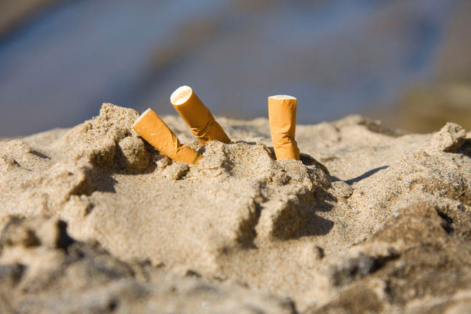
A smoking ban at Ottawa beaches, parks, patios and outside municipal facilities is expected to be rubber-stamped by council after being unanimously approved at committee on Wednesday. The ban would take effect April 2. (FILE PHOTO)

Restaurant owners complaining that a patio smoking ban will kill business won’t get a sympathetic ear from Toni Najem.

The operator of two Firkin Group pubs in Ottawa already prohibits smoking on his patios.

For Najem, it’s personal.

Years working in smoky workplaces led to a lung condition. He bought a coffee shop in the Byward Market so he could work in a smoke-free environment and later got into the pub business.

Snubbing smoking hasn’t hurt his bottom line and he told councillors Wednesday he’s “ecstatic” to have an expanded smoking ban take effect this spring.

The community and protective services committee unanimously approved the ban, which would also cover city beaches, parks and outside municipal facilities.

Council is poised to rubber-stamp the measure during a meeting next Wednesday. The ban would come into effect April 2.

“I think my business will go up,” Najem said outside the committee room.

He said he believes people go to restaurants for good food and atmosphere, not because they want to smoke.

“I think it’s win-win for everybody,” he said.

Public support for the ban has been strong at the committee and public health board meetings. More businesses are coming forward to support the measure, including Courtyard Restaurant owner Paul Wasserman, who made a presentation to the committee.

It appears they are now turning their attention to the National Capital Commission.

Wasserman told councillors that festivals on NCC land will have a “huge competitive advantage” because smoking is allowed on the properties.

Jasna Jennings, executive director of the Byward Market BIA, said those festivals are “direct competition” for businesses and she called on the city to lobby the NCC to create more smoke-free spaces.

Health board chairwoman Diane Holmes and Dr. Isra Levy, the city’s medical officer of health, suggested the NCC was interested in moving quickly on its own smoking ban.

However, NCC spokesman Jean Wolff said it’s “premature” to talk about the agency’s intentions.

Bylaw officers wouldn’t start ticketing businesses and people until July.

For the first months of the smoking ban, officers would only warn offenders about the expanded bylaw.

Susan Jones, head of the city’s emergency and protective services department, said enforcement won’t be just focused on the entertainment districts.

“I guarantee you we will be addressing this wherever there’s a problem,” Jones said.

Ottawa Sun

NCC expects to follow in city's footsteps on smoking ban

Jon Willing
Friday, February 17, 2012, 12:09 PM

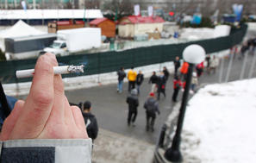
Smoking in Ottawa's Confederation Park on Friday, Feb. 17, 2012. The NCC may follow the city's lead and ban smoking in NCC parks. (TONY CALDWELL/OTTAWA SUN)

National Capital Commission will inevitably embrace a city-like outdoor smoking ban, the agency’s CEO said Friday.

“We’re following very closely what the city is doing because obviously the minute they go ahead with this it will definitely impact ours,” Marie Lemay told reporters at Ottawa City Hall.

“We’re proactively looking into this. If they go ahead with it, chances are we will too.”

The city is one vote away from adopting a smoking ban on restaurant patios and city beaches and parks. The vote will occur Wednesday and the bylaw would come into effect April 2.

Strict enforcement wouldn’t start until July.

Lemay said the NCC doesn’t have a timeline on when it would like to make a decision about a possible smoking ban. The NCC has been talking with the city and will be watching how the bylaw evolves, she said.

“We share event sites and we share parks,” Lemay said.

“You can’t have some parks on one side of the street where you can have smoking and the other one you can’t. At one point there has to be some consistency.”

Earlier this week, some business leaders expressed concern that festivals on NCC land will have a competitive advantage when the municipal outdoor smoking ban begins because people would be able to smoke. The restaurants see those festivals as direct competitors.

Two major festivals, Bluesfest at the Canadian War Museum and the Ottawa Folk Festival at Hog’s Back Park, are on federal land.

Lemay was at City Hall briefing councillors and city staff on the NCC’s Horizon 2067 project, which asks Canadians coast-to-coast what they want out of their national capital.

A draft plan is expected to be presented to the NCC board in the fall.

“My hope is all the research we did will serve more than us,” Lemay said, and she includes the private sector.

Many young Canadians surveyed expressed interest in more cultural and entertainment attractions, like restaurants and bars, and that’s something businesses might consider, she said.

The NCC just finished another planning exercise called Choosing Our Future with the cities of Ottawa and Gatineau.

Lemay said people shouldn’t think the NCC is wrapped up in long-term studies.

The information collected is used in day-to-day decision-making, she said.

Television

CBC News

Ottawa smoking ban passed at committee

Last Updated: Feb 15, 2012 8:48 PM ET

Members of the community and protective services committee voted in favour of the new, updated Ottawa smoking ban Wednesday.

The new regulations, first proposed Jan. 30 by the Ottawa Board of Health, would ban smoking at bar and restaurant patios and at city-run beaches and parks. Smoking would also be prohibited at any festivals held on city property.

Bylaw officers plan to issue warnings to smokers in the spring and help people get used to the new rules. The fines, which are expected to be about $300, would start in the summer.

The enhanced bylaw has already been passed by the board of health and needs just one more stamp of approval from city council, which will vote Feb. 22.

See http://www.cbc.ca/news/canada/ottawa/story/2012/02/15/ottawa-smoking-ban-committee.html for news clip.

Rogers TV

Talk Ottawa with Mark Sutcliffe
Aired Thursday, March 16, 2012

An hour-long program on the proposed smoke-free strategy and bylaw changes was aired on February 15. It featured Councillor Diane Holmes, Chair of the Board of Health and member of the Community and Protective Services Committee; Sherry Nigro, Manager of Health Promotion and Disease Prevention at Ottawa Public Health; Alex Lewis, the Executive Director of the Bells Corners Business Improvement Association; and Jonathan Hatchell, Vice-President of the Royal Oak Pubs.

Although the program could have been a polarized debate given that there were two people representing the health side of the issue and two representing the business side, everyone was basically in favour of the changes being proposed by the City. Mr. Lewis had only one point to make: that businesses should be able to decide for themselves whether or not to allow smoking on their premises. He did, however, acknowledge the health hazards of secondhand smoke. Mr. Hatchell wanted to ensure a level playing field.

All in all, it was a very positive program with very little opposition, especially given the climate 11 years ago when Ottawa was considering smoke-free bars and restaurants.

Radio

CFRA

Pub Owner Excited about Proposed Smoking By-Law

Stephanie Kinsella with Kristi Soble
Wednesday, February 15, 2012

Some residents and business owners are urging city councillors to clear the air and approve the new and expanded smoking by-law recommended by Ottawa Public Health.

One pub owner insists he's ecstatic about the new proposed rules.

Toni Najem says he spent years breathing in second smoke in work environments.

He says his asthma became so bad, he decided to open a coffee shop in the ByWard Market and make it smoke free, before the city implemented the first smoking by-law in 2001.

Najem says customers flocked there and he's found the same for his two pubs in city's west end.

"I think people who get up and go to bars and restaurants they don't say where ca I go smoke, they say where can I go and have a good meal and a great pint."

It's expected the committee will approve the new rules, which would ban smoking at parks, beaches, patios and market stalls.

CFRA

Smoking Ban Debate Heads to Committee

Josh Pringle
Wednesday, February 15, 2012

The debate over smoking on municipal property and bar and restaurant patios will ignite again today at City Hall.

The Community and Protective Services Committee will vote on a proposal from the Board of Health to expand the Smoke Free Ottawa Act.

Under the plan, the City would prohibit smoking in municipal parks, at beaches, on City property and on bar and restaurant patios.

Public Health estimates smoking related illnesses cost almost $40-million per year for hospitalization in Ottawa.

Staff say there would be no new costs associated with enforcing the proposed expanded smoke-free regulations.

Blogs

OpenFile

MorningFile: NCC eyes smoking ban

Posted by Trevor Pritchard on Thursday, February 16, 2012

Next in line for smoking restrictions: Bluesfest? City council's community and protective services committee unanimously approved a prohibition on smoking at restaurant patios, parks, and other public spaces yesterday, and officials suggested that the National Capital Commission—which owns LeBreton Flats, where Bluesfest is held—is keeping an eye on what the city is doing. While an NCC spokesperson said it was too soon to talk about specifics, Dr. Isra Levy, Ottawa's medical officer of health, says the commission is interested in moving "quickly" on implementing a smoking ban.

